Car Rental System



**L.J. Institute of Computer Application**

**GROUP NO:**

**MCA_2_13**

**Internal Guide:**

**Het Rachh**

**Project By:-**

**Sufyan Mansuri 205170694116**

**Harshil Patel 205170694099**

**Dipak Shahu 205170694104**

**GUJARAT TECHNOLOGICAL UNIVERSITY (GTU)**

**COMPLETION CERTIFICATE**

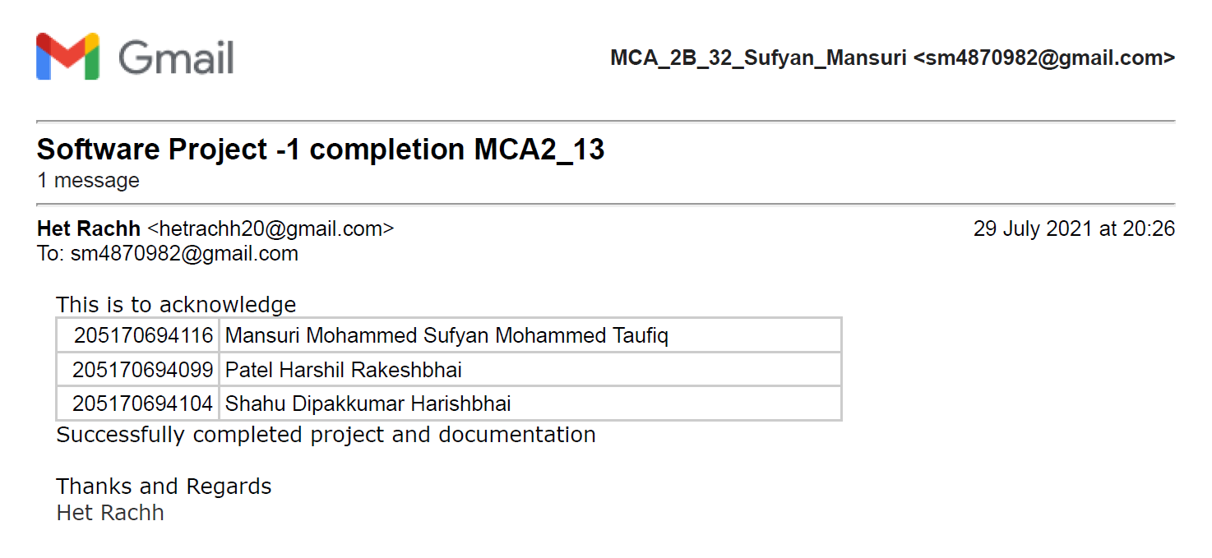

# **Table of Contents**

# **Introduction …**……………………………………………………….....4

# Existing System ………………………………………………..… 5

# Need for the New System …………………………………………….…. 5

# Objective of the New System ………………………………………….... 5

# Problem Definition …………………………………………………….... 5

# Core Components …………………………………………………………6

# Project Profile ………………………………………………………….…6

# Assumptions and Constraints ……………………….……………….……7

# Advantages and Limitations of the Proposed System ………………….…7

# **Requirement Determination & Analysis …**…………………….……..8

# Requirement Determination ……………………………………….......….9

# Targeted Users …………………………………………………………….9

# **System Design …**…………………………………………………...….10

# Use Case Diagram ………………………………………………………..11

# ER Diagram ……………………………………………………………12

# Class Diagram ……………………………………………………………13

# Interaction Diagram ………………………………………………………14

# Activity Diagram …………………………………………………………18

# Data Dictionary ………………………………………………………......19

# **Development …**………………………………………………………...24

# Coding Standards …………………………………………………………24

# Screenshots ………………………………………………………….……25

# **Proposed Enhancements …**………………………………………...…47

# **Conclusion …**…………………………………………………………..48

# **Bibliography …**………………………………………………………...49

# **Introduction**

# 1. Introduction

Car rental system allows individuals to book a self-drive rental car by the day, week, or month. It seamlessly integrates into any platform as it is a web app. Our service enables users to rent cars for traveling in the city or outstation.

# 1.1. Existing System

Currently users book car using the traditional manual system of vehicle reservation

through calling or visiting at store.

# 1.2. Need For the New System

To eliminates the risk of erroneous booking and reduce overall lead time online booking system needed.

# 1.3. Objectives of the New System

The objective of the project is to automate vehicle rental reservation so that the customers do not need to call and spend unnecessary time to reserve a vehicle.

And for the company process become easier to manage bookings and cars on

system rather than manual.

* Customer is only needed to provide Aadhar number instead of submitting

Identity document.

# 1.4. Problem Statement

Customer inquire the company to rent a car. Admin validates the request and ask for security proof. Company asks customer to pay security deposit. After validating the request company can approve or reject car rental request with valid reasons. Then

customer is asked to pay booking amount in advance or after the completion of booking. Security proof is returned to the customer after booking period.

1.5. Core Components

Core components of this projects are

* **User module**
  + Login/Logout.
  + View fleet.
  + View their transaction history.
  + View & manage their account details.
  + View & give testimonial.
  + Request inquiry.
* **Admin module**
  + Login/Logout.
  + Admin can manage fleet.
  + Manage bookings.
  + Manage users.
  + View testimonials.
  + Manage inquires.
* **Visitor module**
  + Register.
  + View fleet.
  + View Testimonials.
  + Request inquiry.

Customers can submit the request, see the status of their request anytime as this system works online.

As the data is saved in database it is easy for admin to generate reports. As it can be done easily in this system.

1.5. Project Profile

* **Name:** Car Rental System
* **Technologies:**
  + Front End: HTML, CSS, JavaScript
  + Back End: Django (Python)
  + Database: MySQL

# 1.7. Assumptions and Constraints

* **Assumptions**
  + All group members have required skills.
  + All of the PC/Laptops are in good conditions.
  + All needed resources will be available.
  + Active internet connection is available to all members.
* **Constraints**
  + Project needs to completed in the span of two months.
  + Group members need to learn Django.
  + We need to take references from websites as local business can’t be visited due to current ongoing pandemic situation.

# 1.8. Advantages and Limitations of Proposed System

* **Advantages**
  + Automated System
  + Saves time and cost
  + The car rental system present instant support to the clients.
  + The car rental system gives an easy booking facility for the clients.
  + The receipts can be easily generated from the rental system.
  + The clients can make advance payment online and bookings for the cars.
* **Limitations**
  + Internet Connectivity
  + Limited Pickup & Drop Points
  + GPS tracking

# 

# 

# 

# 

# 

# 

# 

# 

# 

# **Requirement Determination & Analysis**

# 2.1. Requirement Determination

The existing system that is manual, customers contact the company for booking. Customers submits identity document and pay security deposit and receipt is given to them for their booking. We decided to use Zoom Car as reference. Then our project team determined the system can be built with fulfilled requirements using Django framework.

# 2.2. Targeted Users

* User
* Visitor
* Admin

# 

# 

# 

# 

# 

# 

# 

# 

# 

# 

# 

# **System Design**

# 3.1. Use Case Diagram

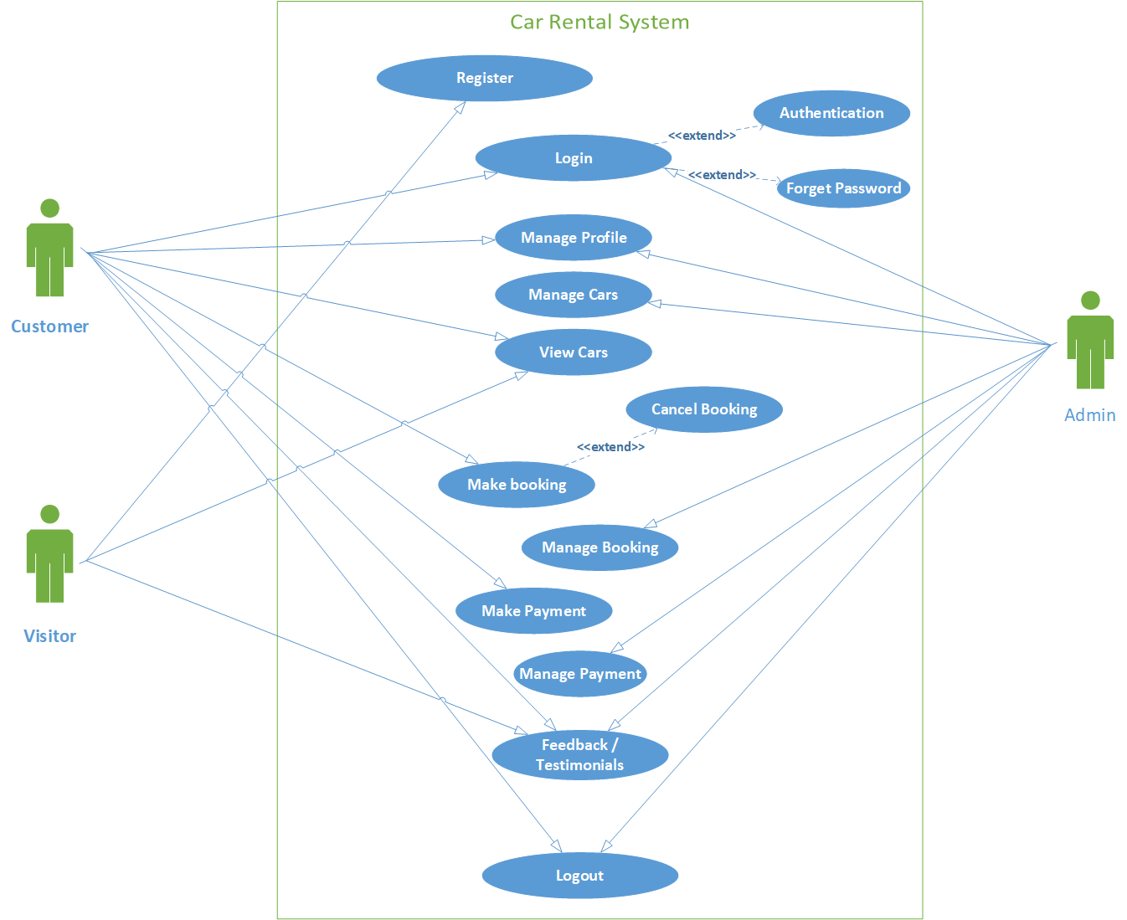

# 3.2. ER Diagram

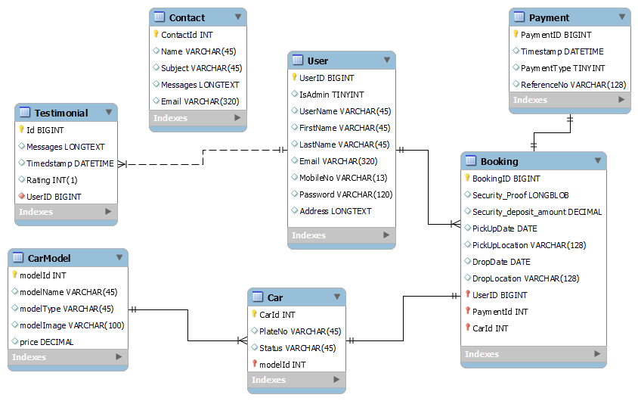

# 3.3. Class Diagram

# 

# 3.4. Interaction Diagram

# REGISTRATION

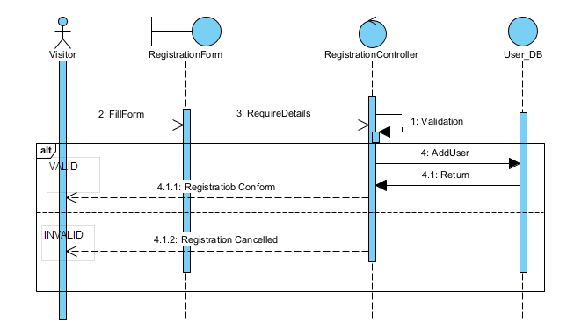

LOGIN

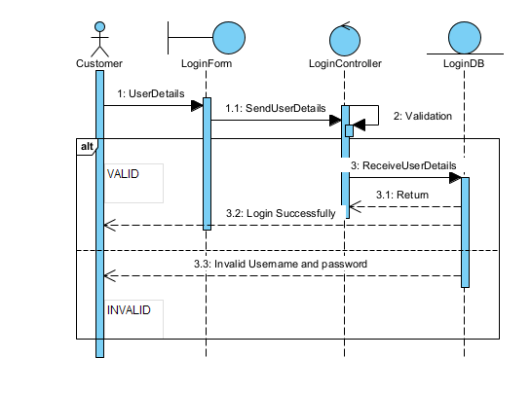

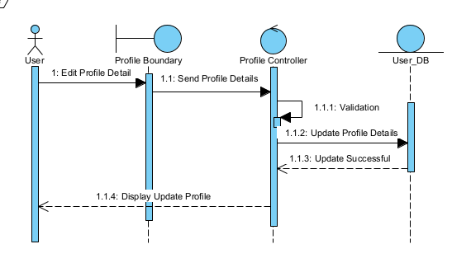MANAGE PROFILE

VIEW CAR

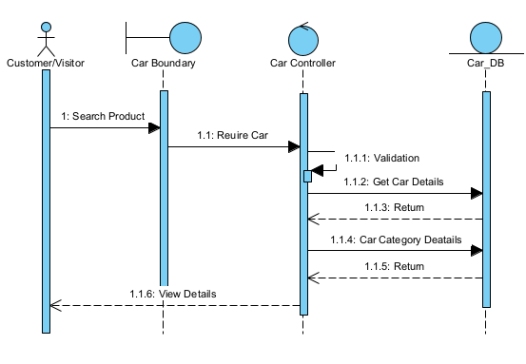

MANAGE CAR

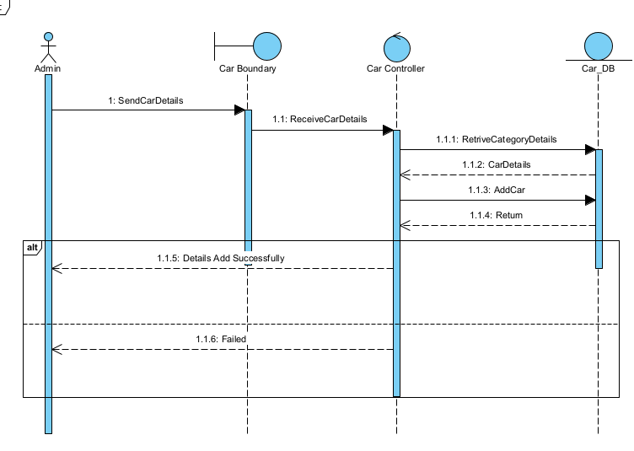

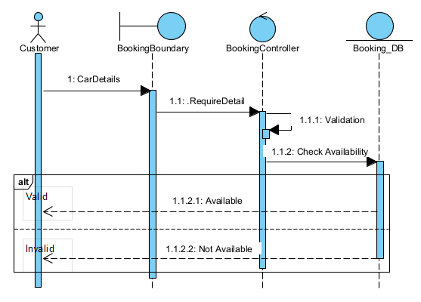Booking CAR

MAKE PAYMENT

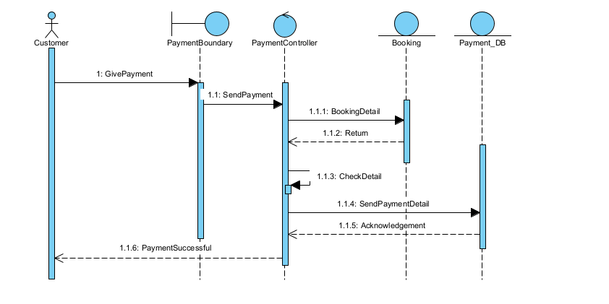

TESTIMONIAL

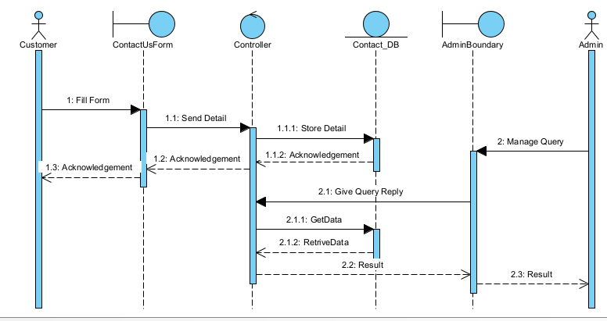

# 3.5. Activity Diagram

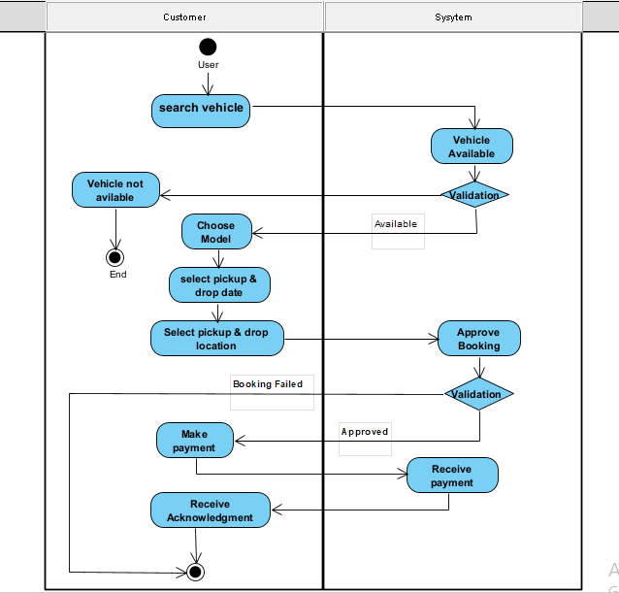

# 3.6. Data Dictionary

**Table Name:** User

**Table Description**: stores the user information.

|  |  |  |  |  |
| --- | --- | --- | --- | --- |
| **Column** | **Type** | **Constraints** | **Desciption** | **Sample Data** |
| UserId | BIGINT(15) | PIMARY KEY | Id of user | 1 |
| IsAdmin | TINYINT(1) | NOT NULL | Role of user  0: Admin, 1: Not Admin | 1 |
| UserName | VARCHAR(45) | NOT NULL,  UNIQUE | Website Name of user | dipakShahu |
| FirstName | VARCHAR(45) | - | Name of user | Dipak |
| LastName | VARCHAR(45) | - | Last name of user | Shahu |
| Email | VARCHAR(320) | NOT NULL,  UNIQUE | Email of user | [ds@gmail.com](mailto:ds@gmail.com) |
| MobileNo | VARCHAR(13) | UNIQUE | Mobile no of user | +917926199912 |
| Password | VARCHAR(120) | NOT NULL | Password of user account | pbkdf2_sha256$260000… |
| Address | LONGTEXT | - | Address of user | B/20, Gota, Ahmedabad, Gujarat |

**Table Name:** Booking

|  |  |  |  |  |
| --- | --- | --- | --- | --- |
| **Column** | **Type** | **Constraints** | **Desciption** | **Sample Data** |
| BookingId | BIGINT(15) | PRIMARY KEY | Id of Booking | 1 |
| SecurityProof | LONGBLOB | NOT NULL | Id proof of user | booking-security Proof.bin |
| SecurityDepositAmount | DECIMAL(7,2) | NOT NULL | Deposit amount | 2499.00 |
| PickUpDate | DATE | NOT NULL | Car Pick up date | 2021-07-13 |
| PickUpLocation | VARCHAR(128) | NOT NULL | Pick up location | Ahmedabad Railway-station |
| DropDate | DATE | NOT NULL | Car Drop date | 2021-07-18 |
| DropLocation | VARCHAR(128) | NOT NULL | Drop location | Ahmedabad Railway-station |
| UserId | BIGINT(15) | FOREIGN KEY | Reference of user table | 1 |
| PaymentId | BIGINT(15) | FOREIGN KEY | Reference of user payment | 1 |
| CarId | INT(11) | FOREIGN KEY | Id of car | 1 |

**Table Description**: stores the booking details.

**Table Name:** Car

**Table Description**: stores the car details.

|  |  |  |  |  |
| --- | --- | --- | --- | --- |
| **Column** | **Type** | **Constraints** | **Desciption** | **Sample Data** |
| CarId | INT (11) | PRIMARY KEY | Id of car | 1 |
| PlateNo | VARCHAR(10) | NOT NULL | Plateno of car | GJ01VH1234 |
| Status | TINYINT(1) | NOT NULL | Status of car  0: Available, 1: Booked, 2: Maintenance | 0 |
| ModelId | INT(11) | FOREIGN KEY | Reference of model table | 1 |

**Table Name:** Car Model

**Table Description**: stores the car information.

|  |  |  |  |  |
| --- | --- | --- | --- | --- |
| **Column** | **Type** | **Constraints** | **Desciption** | **Sample Data** |
| ModelId | INT(11) | PRIMARY KEY | Id of model | 1 |
| ModelName | VARCHAR(45) | NOT NULL | Name of model | Hundai i10 |
| ModelType | VARCHAR(45) | NOT NULL | Modeltype of car | Hatchback |
| ModelImage | VARCHAR(100) | NOT NULL | Image of car | media/blog-4-720x480_U51gd2E.jpg |
| Price | DECIMAL(7,2) | NOT NULL | Price of car | 1350.00 |

**Table Name:** Testimonial

|  |  |  |  |  |
| --- | --- | --- | --- | --- |
| **Column** | **Type** | **Constraints** | **Desciption** | **Sample Data** |
| TestimonanialId | BIGINT(15) | PRIMARY KEY | Id of testimonial | 1 |
| Message | LONGTEXT | NOT NULL | Messages of user | Hello World |
| Timestamp | DATETIME | NOT NULL | Date and time of user | 2021-07-09 16:26:42.210756 |
| Rating | TINYINT(1) | NOT NULL,  Rating >= 1 and Rating <= 5 | Rating of user | 5 |
| UserId | BIGINT(15) | FOREIGN KEY | Reference of user table | 1 |

**Table Description**: stores the user information.

**Table Name:** Payment

**Table Description**: stores the payment details.

|  |  |  |  |  |
| --- | --- | --- | --- | --- |
| **Column** | **Type** | **Constraints** | **Desciption** | **Sample Data** |
| PaymentId | BIGINT(15) | PRIMARY KEY | Id of Payment | 1 |
| Timestamp | DATETIME | NOT NULL | Date and time of user | 2021-07-09 16:26:42.210756 |
| PaymentType | TINYINT(1) | NOT NULL | Type of payment | 1 |
| ReferenceNo | VARCHAR(128) | NOT NULL | Reference number of payment | ipi_1IH5Vo2eZvKYlo2CKPRLvsz3 |

**Table Name:** Contact

**Table Description**: stores the contact data filled by user or visitor.

|  |  |  |  |  |
| --- | --- | --- | --- | --- |
| **Column** | **Type** | **Constraints** | **Desciption** | **Sample Data** |
| ContactId | INT(15) | PRIMARY KEY | Id of Payment | 1 |
| Name | VARCHAR(45) | NOT NULL | Name of user | Dipak |
| Subject | VARCHAR(45) | NOT NULL | Subject of contact | Car inquiry |
| Message | LONGTEXT | NOT NULL | Message fo subject | “Hello world!” |
| Email | VARCHAR(320) | NOT NULL | Email of user | ds9952@gmail.com |

# **Development**

Development of this project started with a user interface, the work of select a user interface was given to Dipak Shahu, he would select a simple user-friendly interface where user can have options suitable for him / her. After user interface the basic functionality like login and logout was to be made. The login and logout functionality were done by Sufyan Mansuri. Then after login user would have basic options like home page, submit request, change password and logout. These form layouts were designed by Harshil Patel. The request submission form with validations and storing in database and application logic were made by Sufyan Mansuri. Change password functionality was made by Sufyan Mansuri. And documents were made by Dipak Shahu and Harshil Patel.

These modules were made and tested independently and then integrated using git to make the whole system. GitHub was used to store repository remotely.

# 4.1. Coding Standards

Coding standard of this projects were

➢ At Least one blank line between functions.

➢ At least two blank lines between classes.

➢ Proper Indentation in every type of file.

➢ Single space before and after operators, except in parameters.

➢ Every item on new line in case of lists, dictionaries, etc.

➢ Every word should be case sensitive in variable and function names.

# 4.2. Screenshots

**Index Page:**

**This page is shown when someone visits the website.**

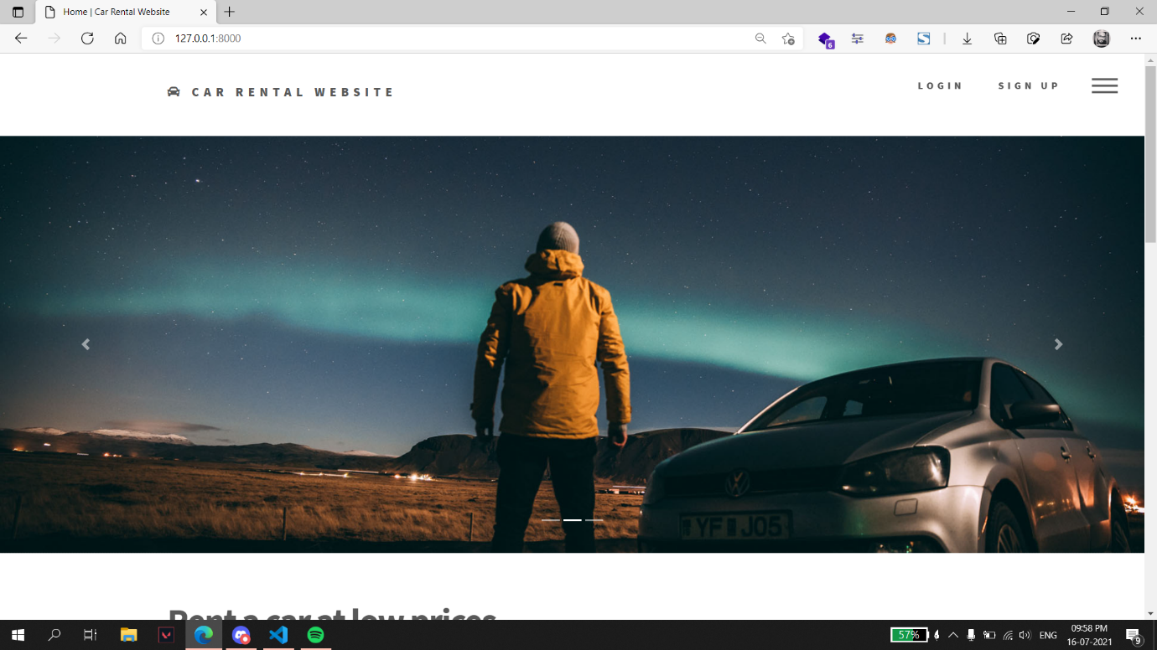

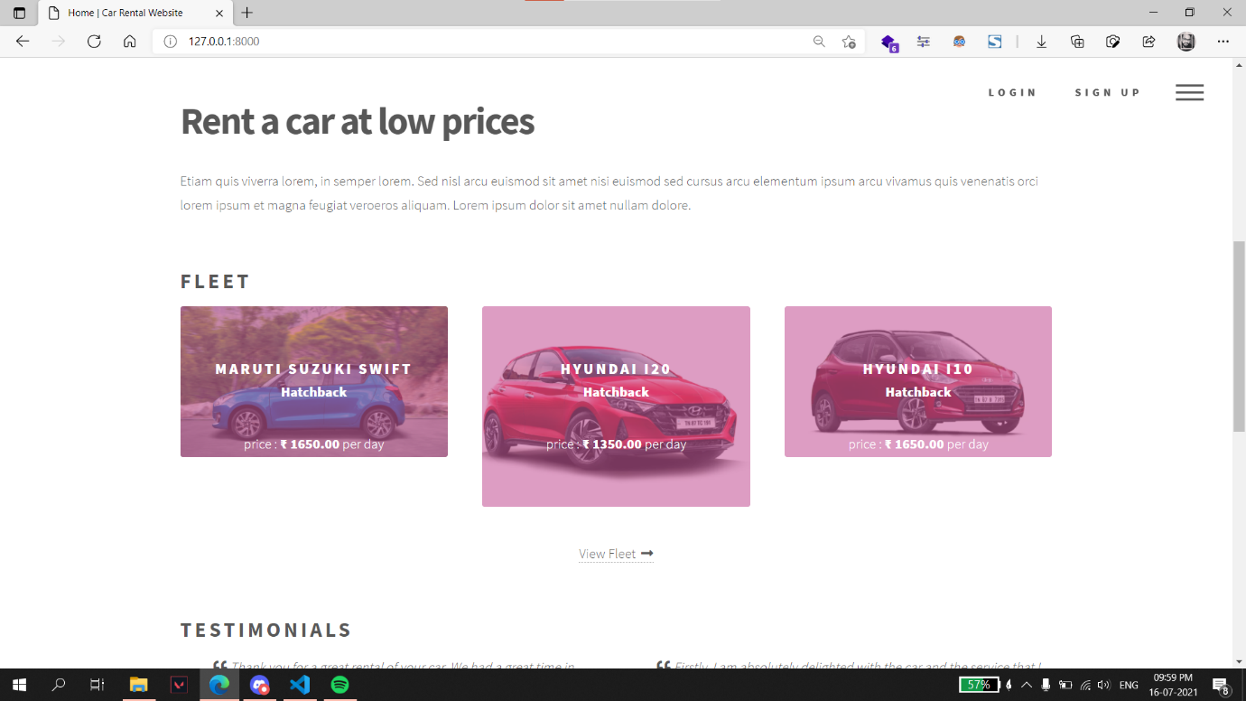

# 

**Fleet:**

**Cars are displayed on this page.**

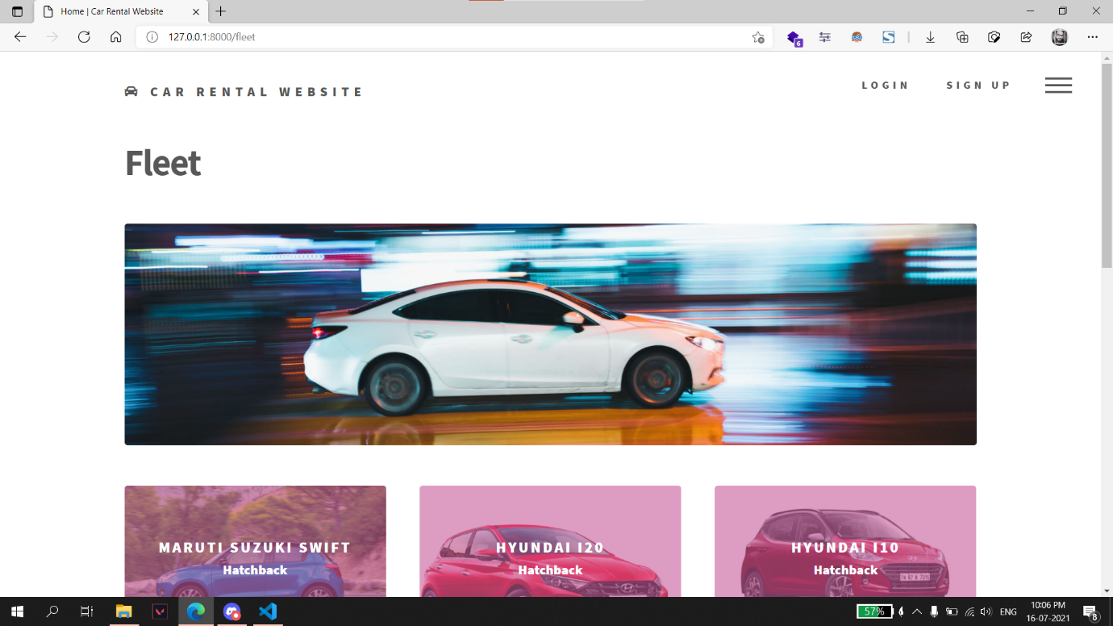

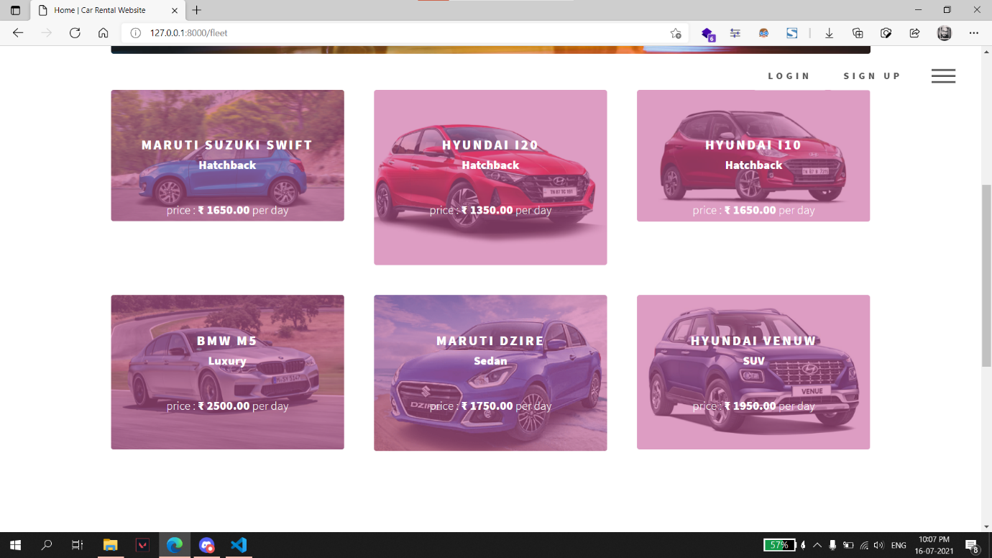

**About Us:**

**Information regarding the website is shown on this page.**

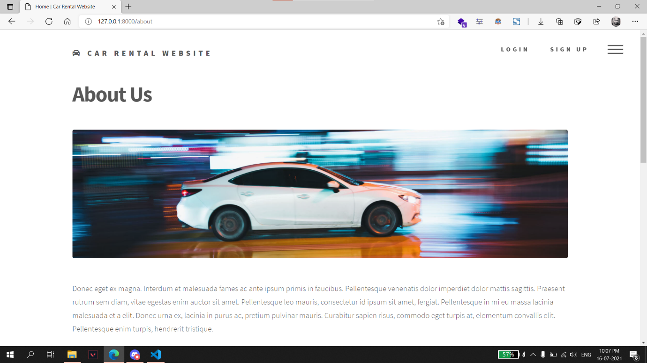

**Team:**

**Team member details is shown on team page.**

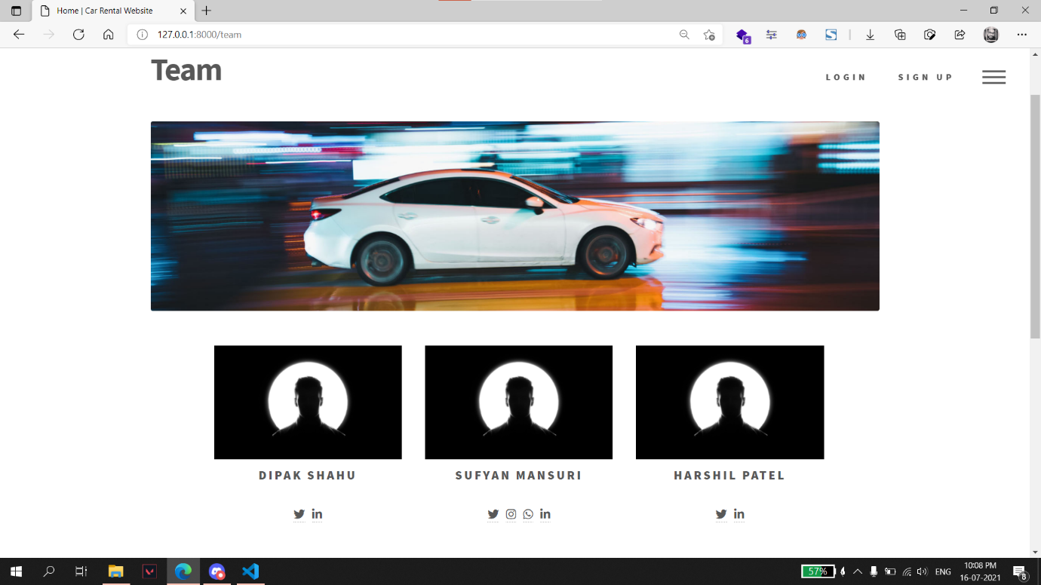

**Testimonials:**

**Customer testimonials are displayed on this page.**

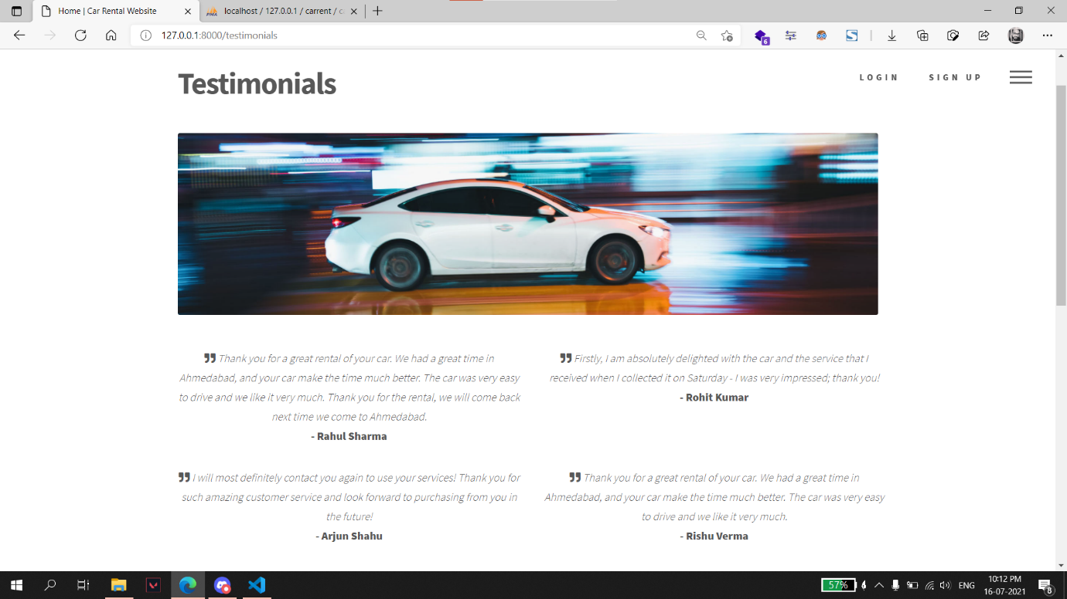

**FAQ:**

**Frequently asked questions about the service and their answers are displayed on this page.**

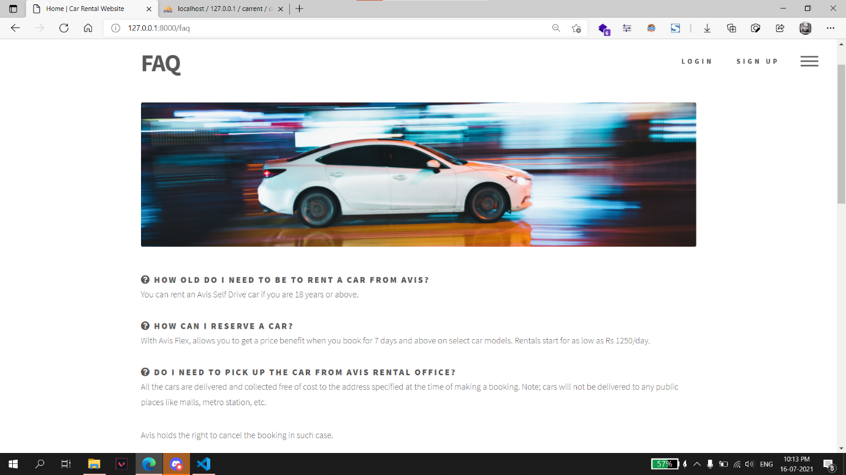

**Terms:**

**Terms & Conditions are shown on this page.**

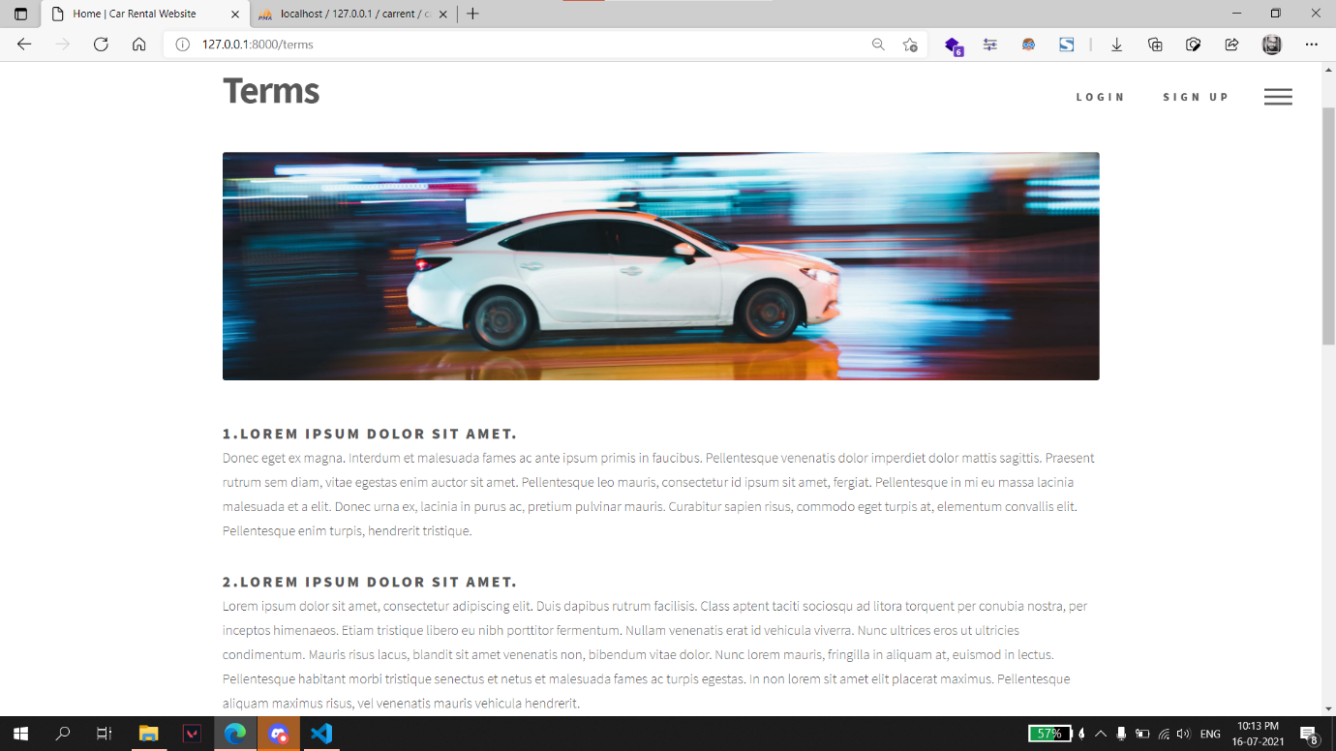

**Contact Us:**

**User can submit any queries regarding the service on this page.**

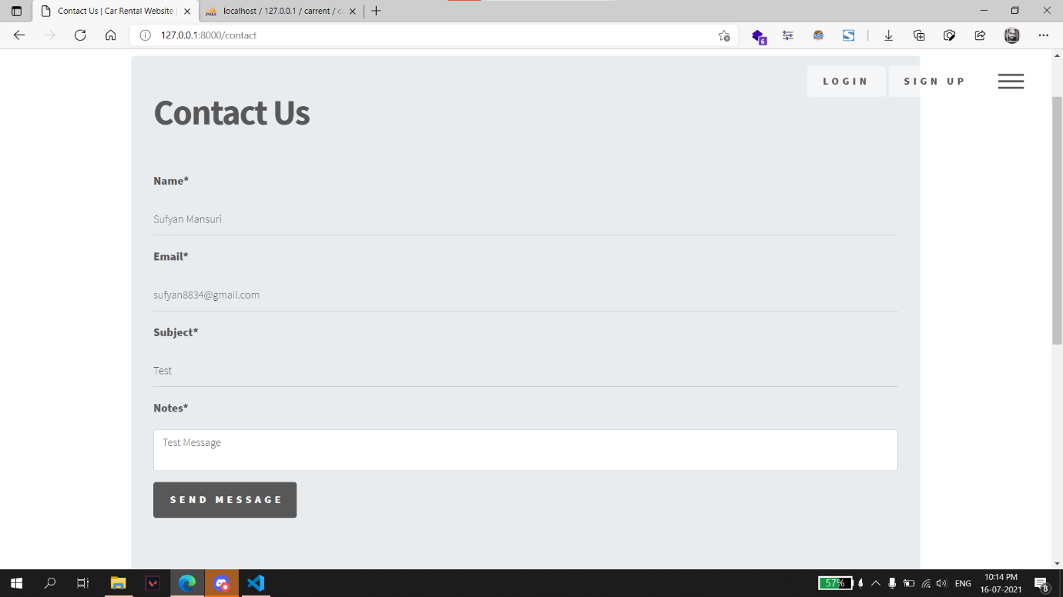

* **A message is displayed on the page on the page regarding the success or failure of the form submission.**

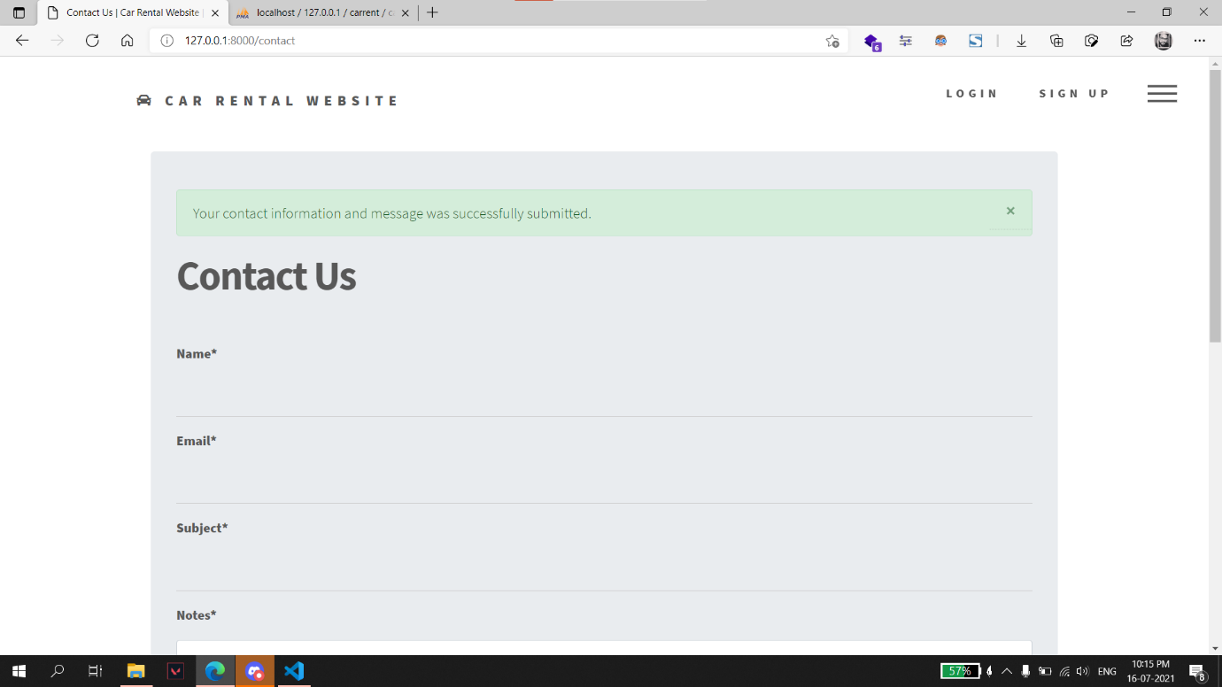

**Signup:**

**Users can create a new account on signup page.**

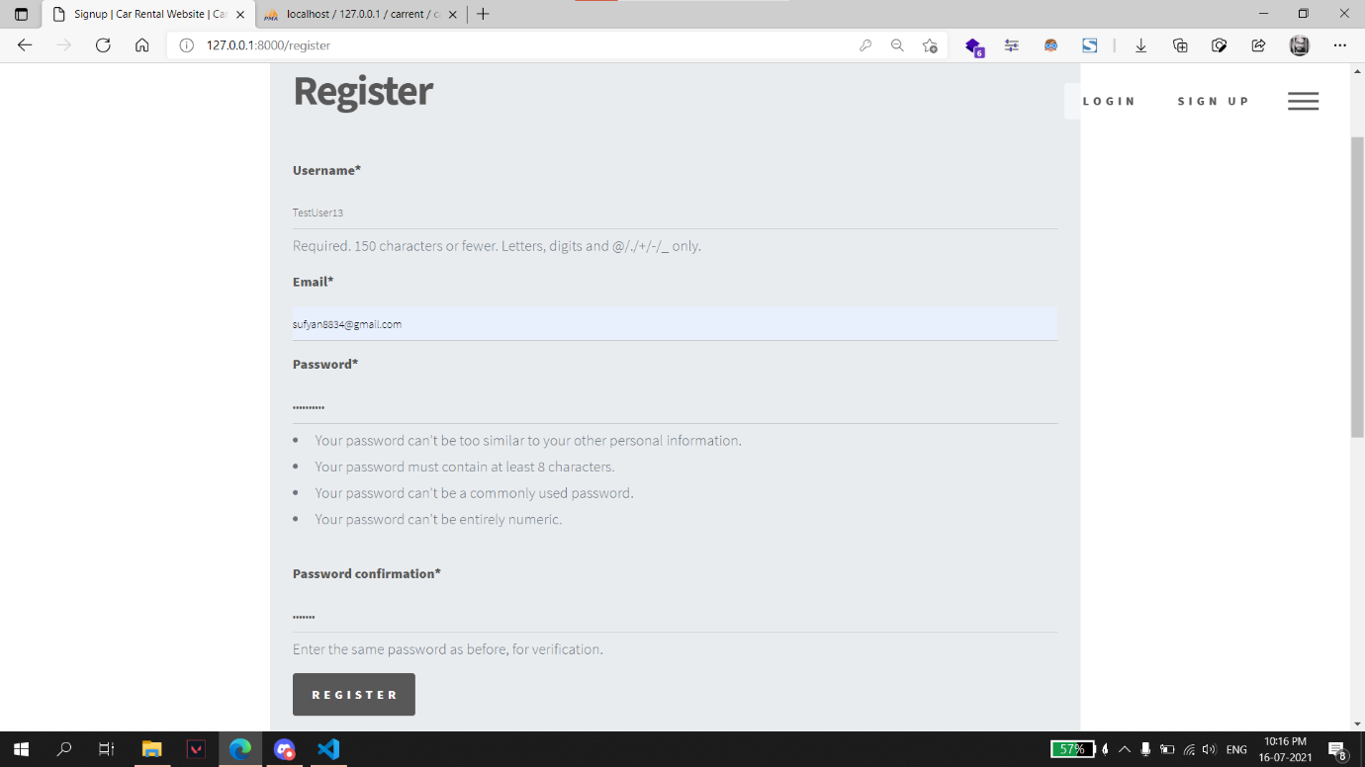

* **Signup form is validated and appropriate message is displayed to the user regarding the successful or unsuccessful registration.**

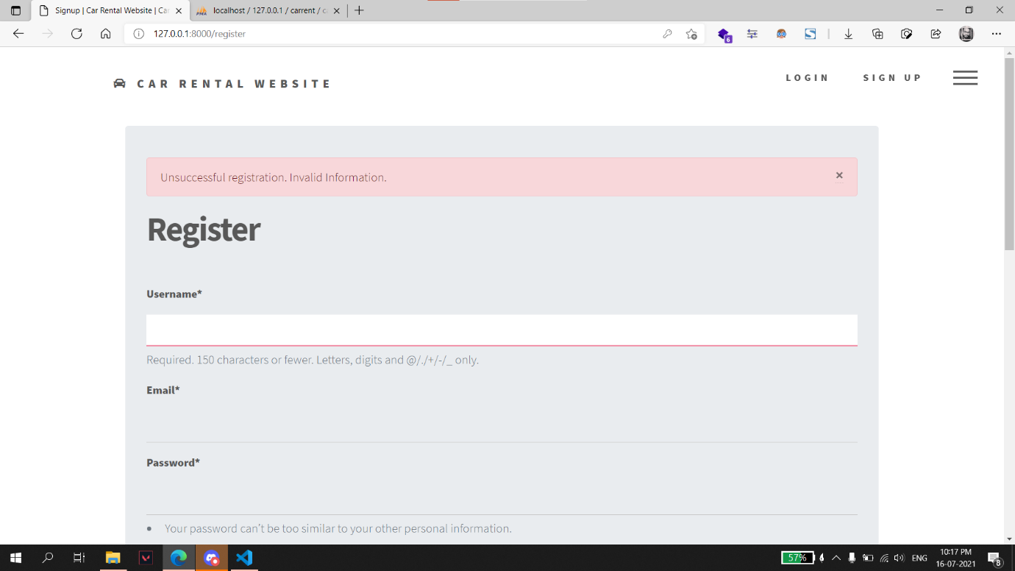

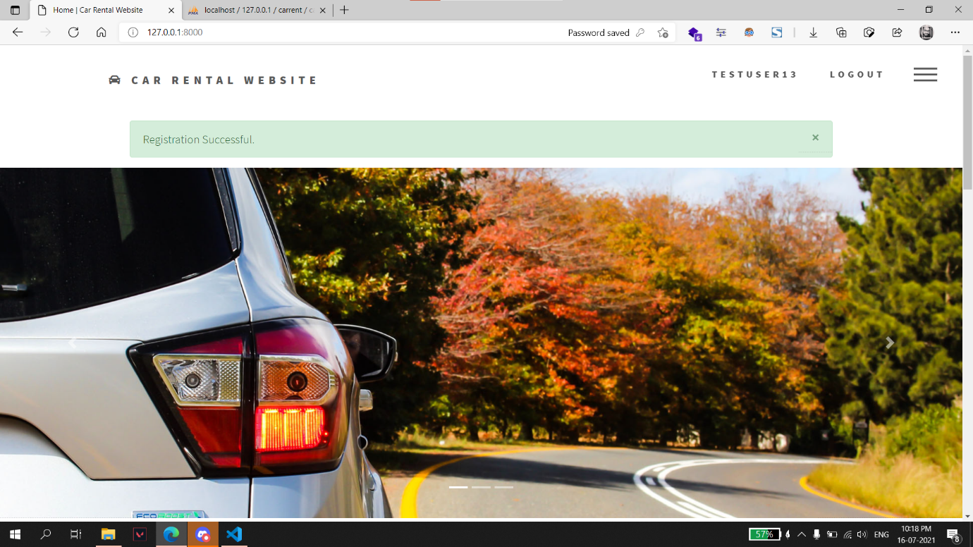

**Login:**

**Existing users can login from this page.**

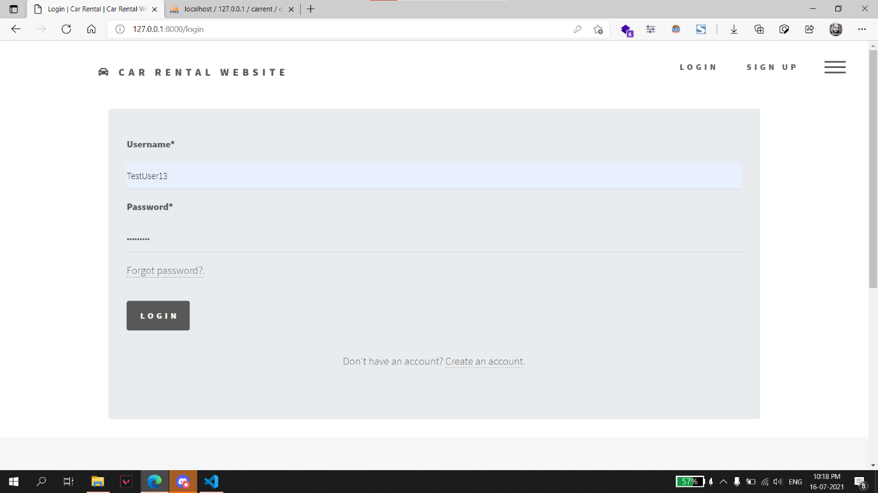

* **User is redirected to index page with a message on successful login.**

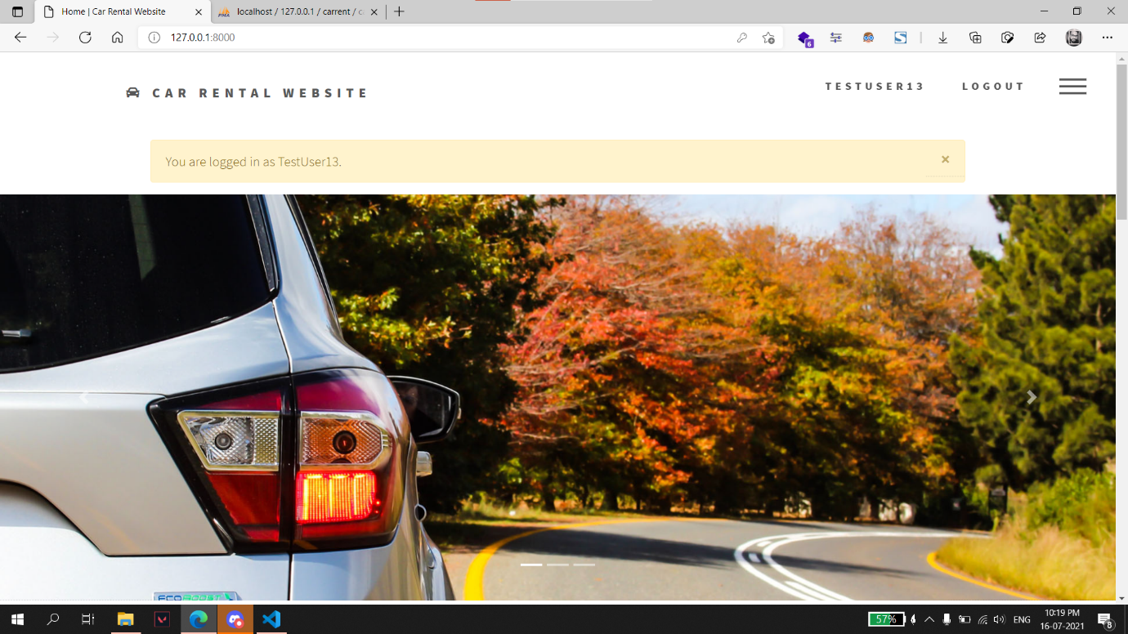

* **An error message is displayed to the user when invalid information is submitted.**

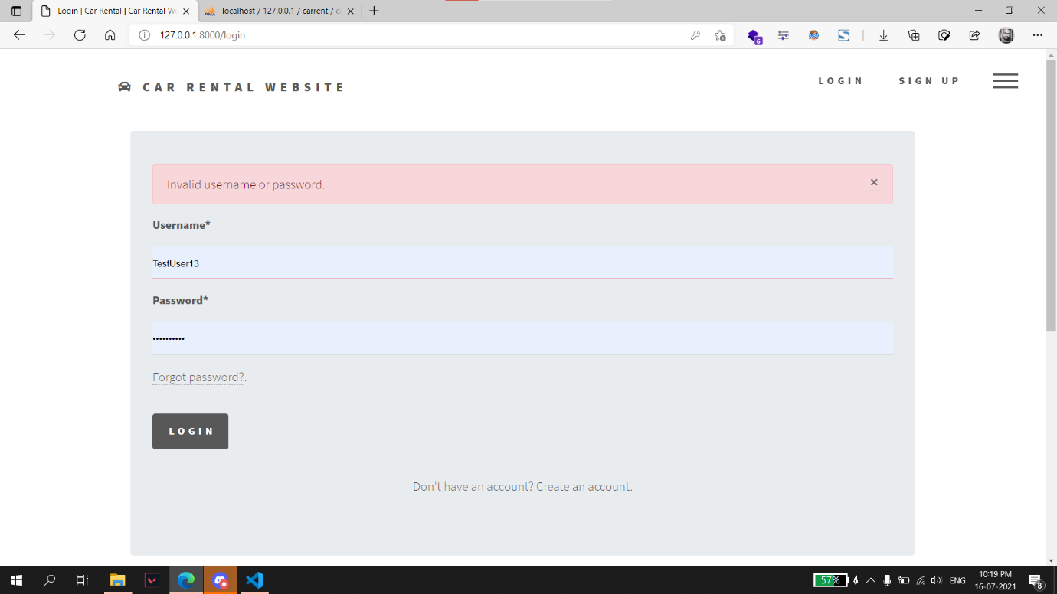

**Password Reset:**

**User can reset password from this page.**

1. **Enter email address associated with the account.**

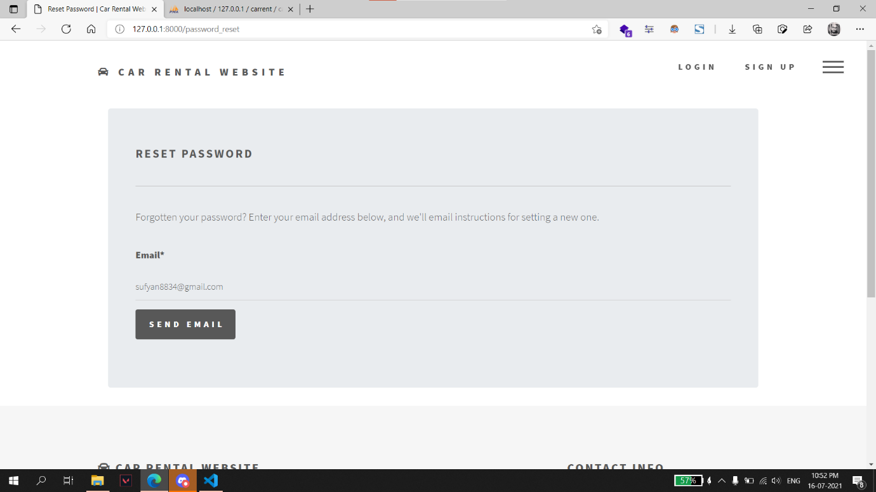

1. **An email with link to reset password is sent to the submitted email address.**

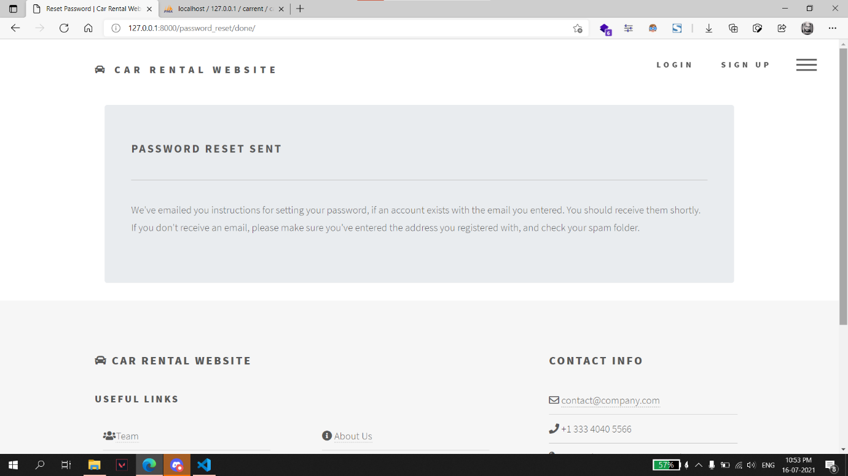

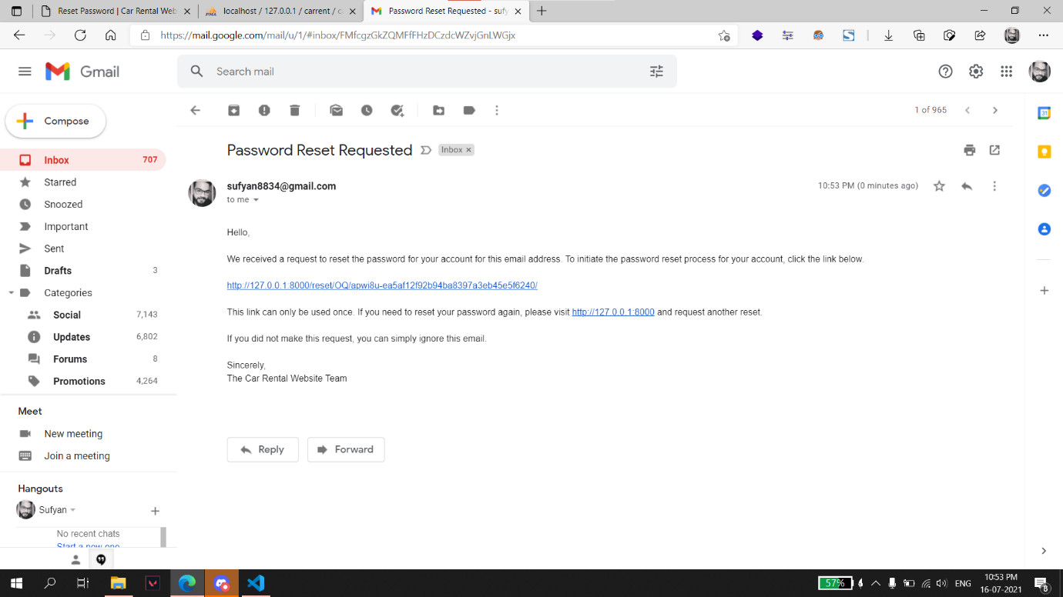

1. **User enters new password.**

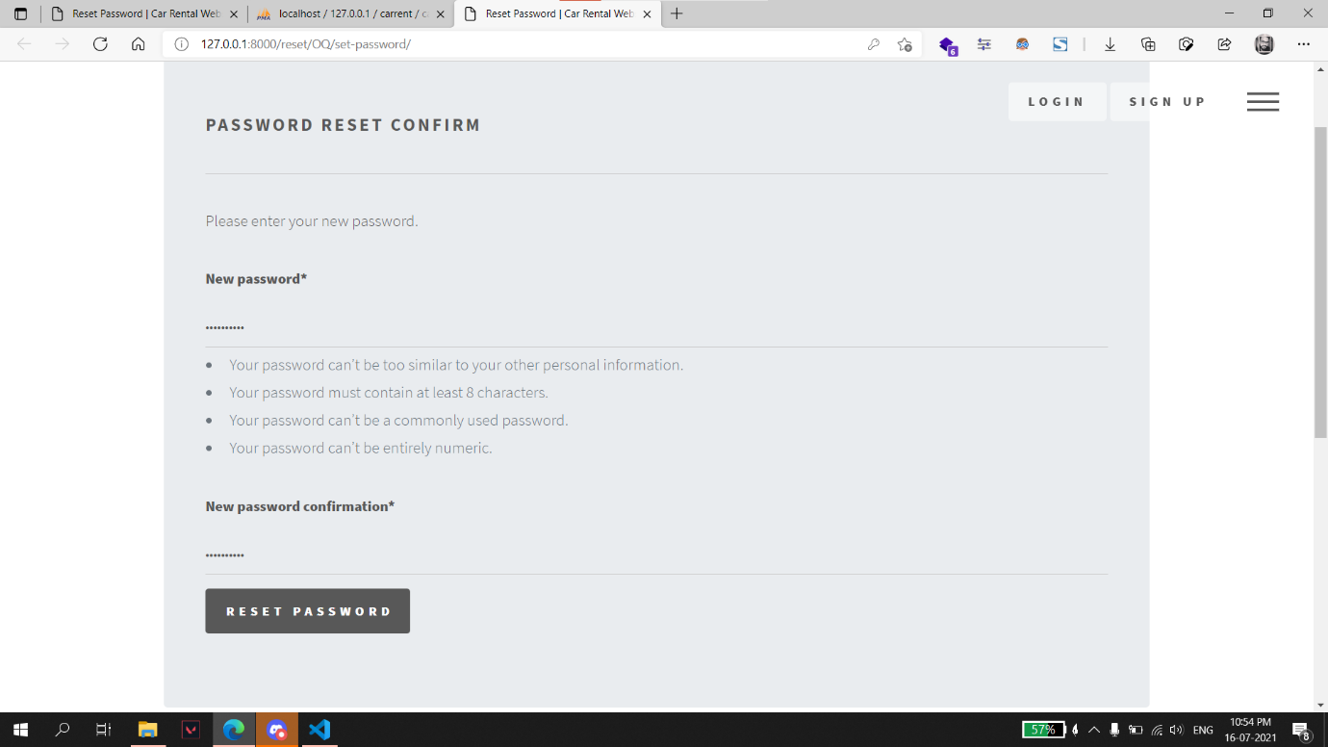

1. **This page is displayed on resetting the password successfully.**

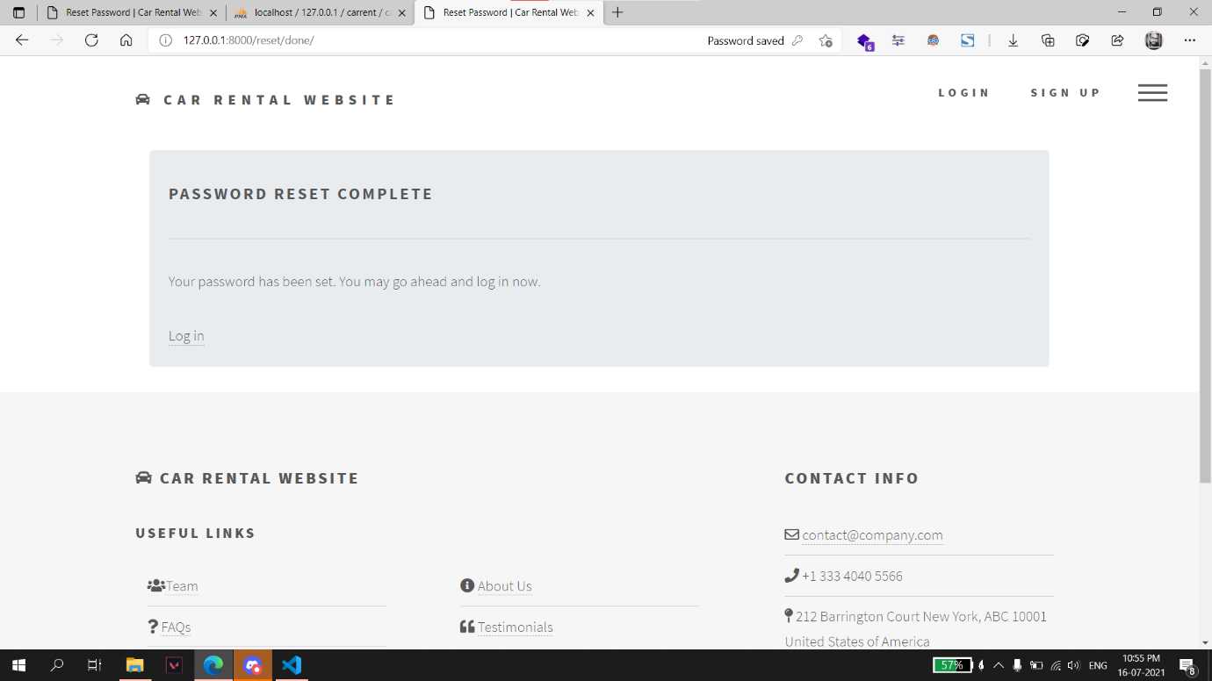

**Profile:**

**User can update profile details on this page.**

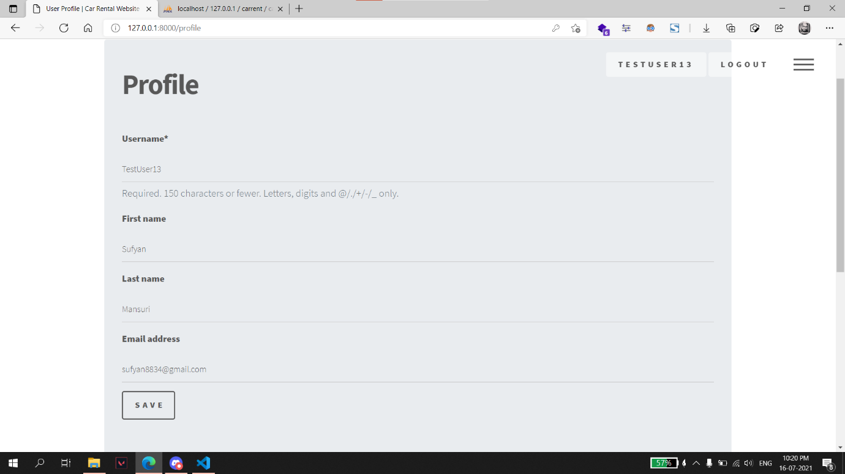

# 

**Booking:**

**User can book a car for rent using this page.**

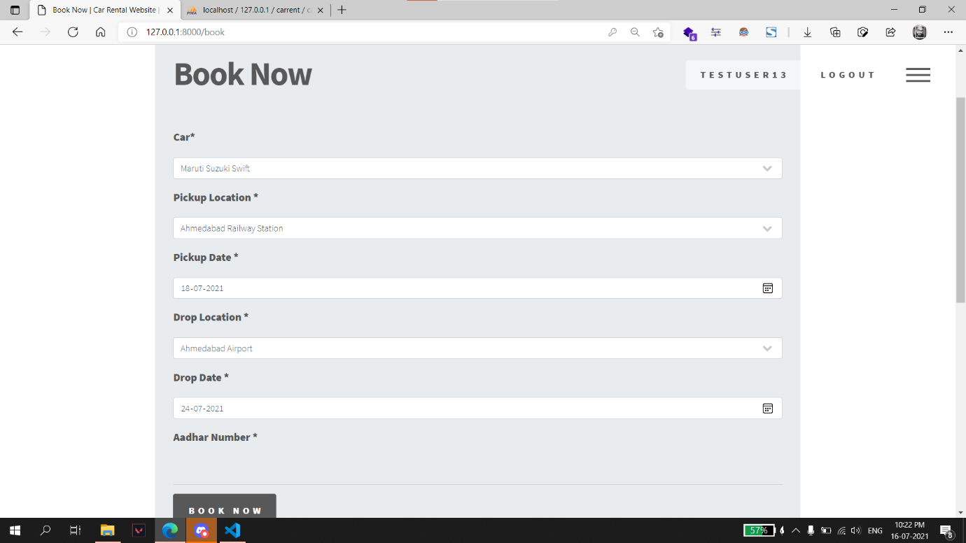

* **Aadhar number validation.**

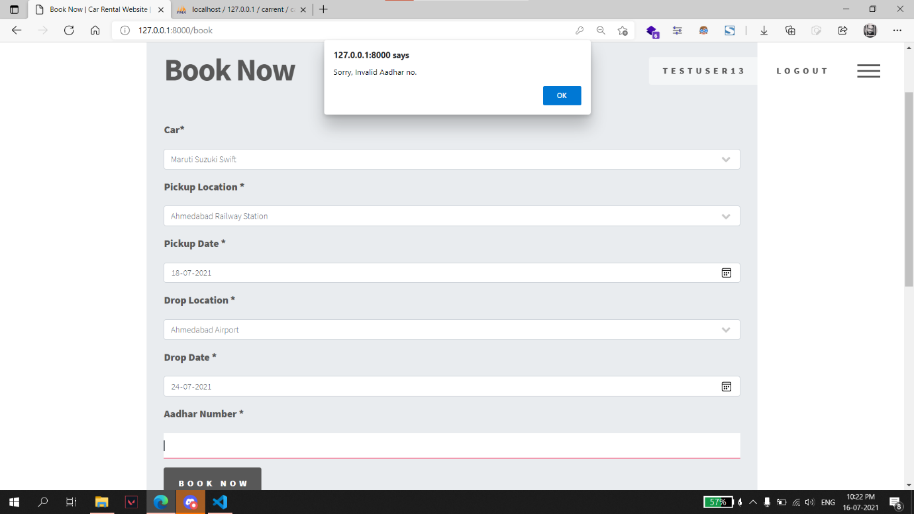

* **User is redirected to this page on successful submission of booking form.**

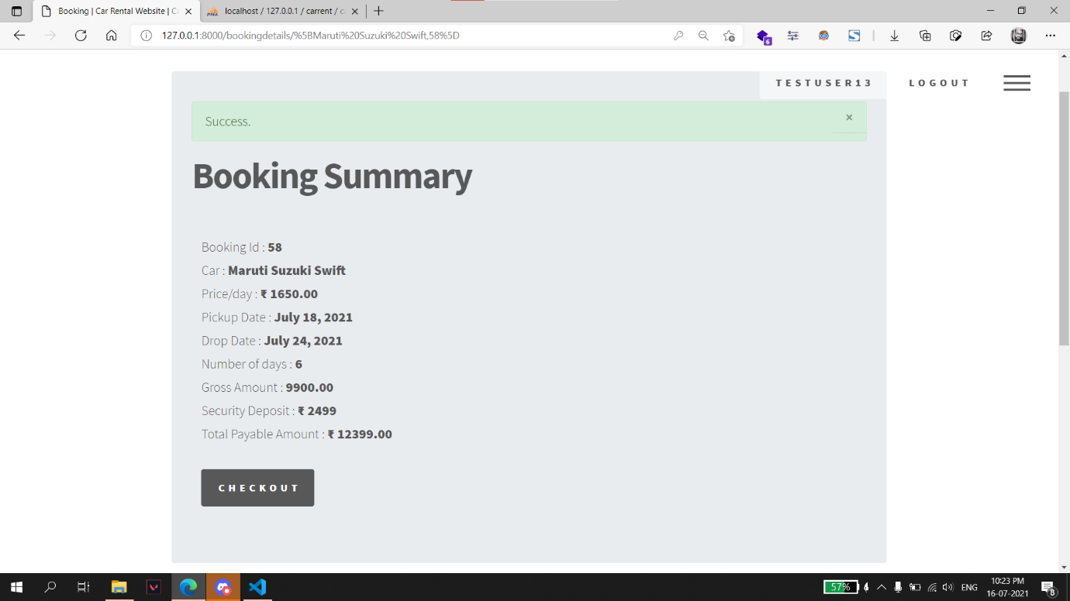

* **An error message is displayed on the page if selected car is not available for booking.**

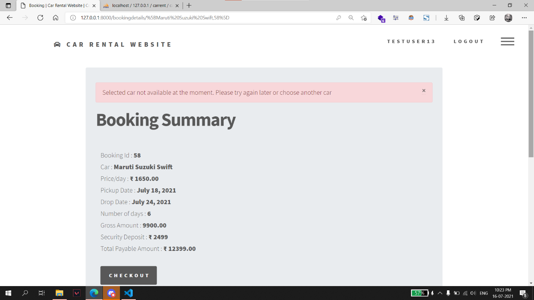

* **User is redirected to “Booking History” page after checkout.**

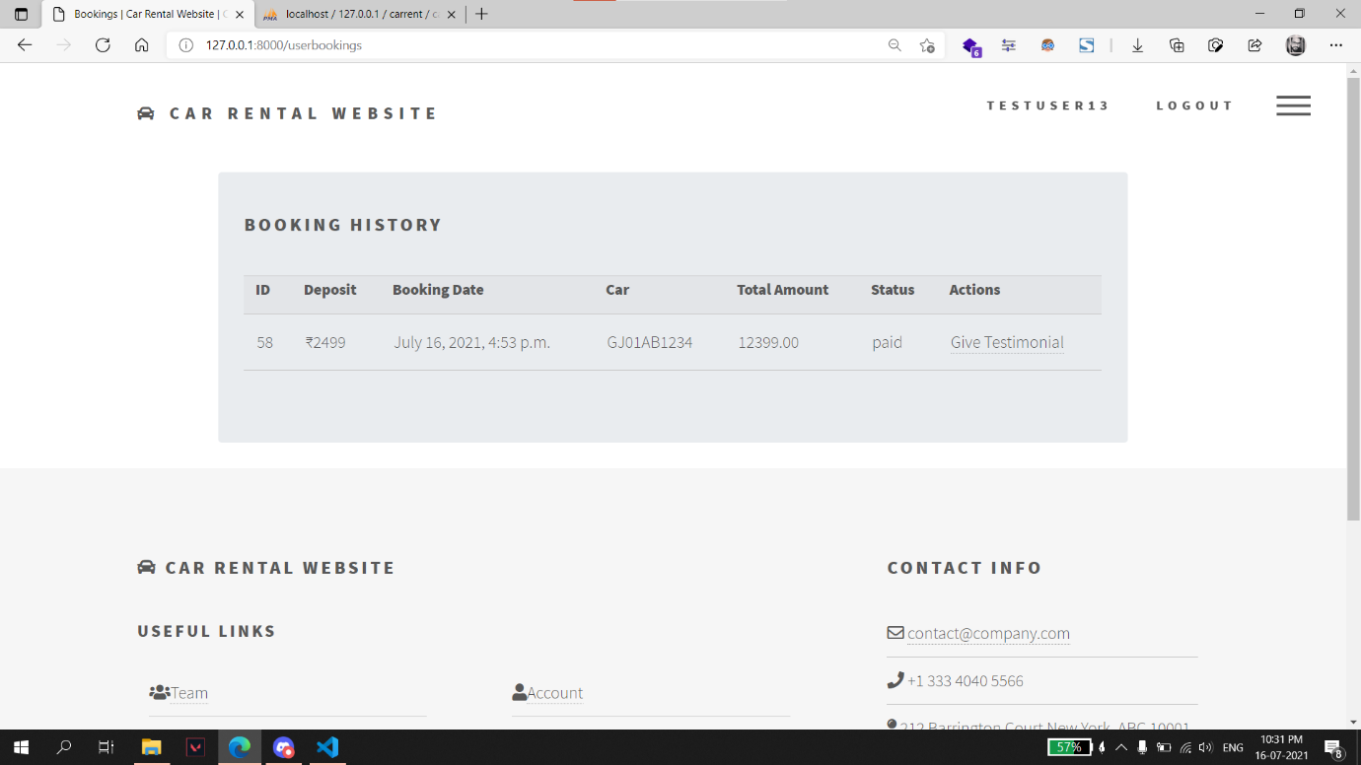

* **Customer can choose to give testimonial from this page.**

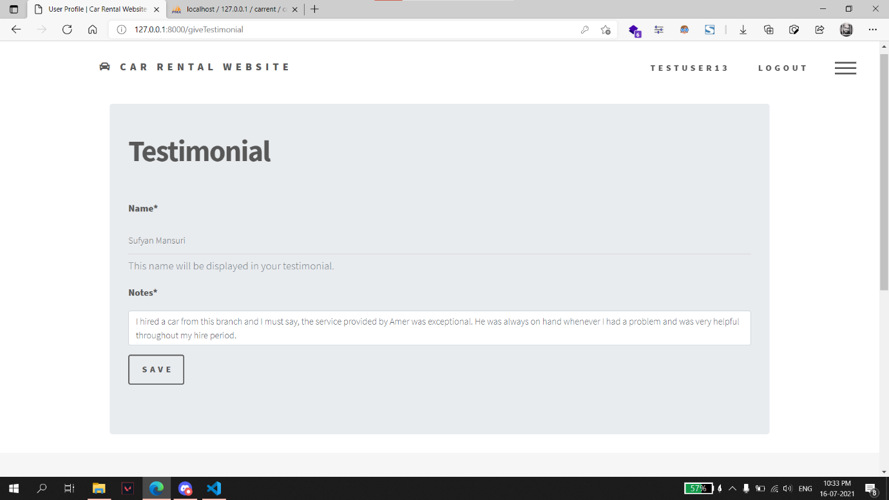

* **On successful submission of the form customer’s testimonial is added on “Testimonials” page with a success message.**

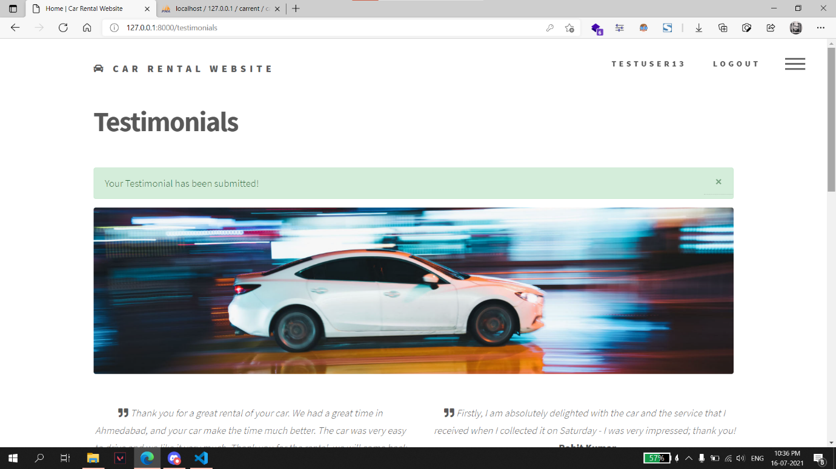

**Logout:**

**A message is shown to the user on successful logout.**

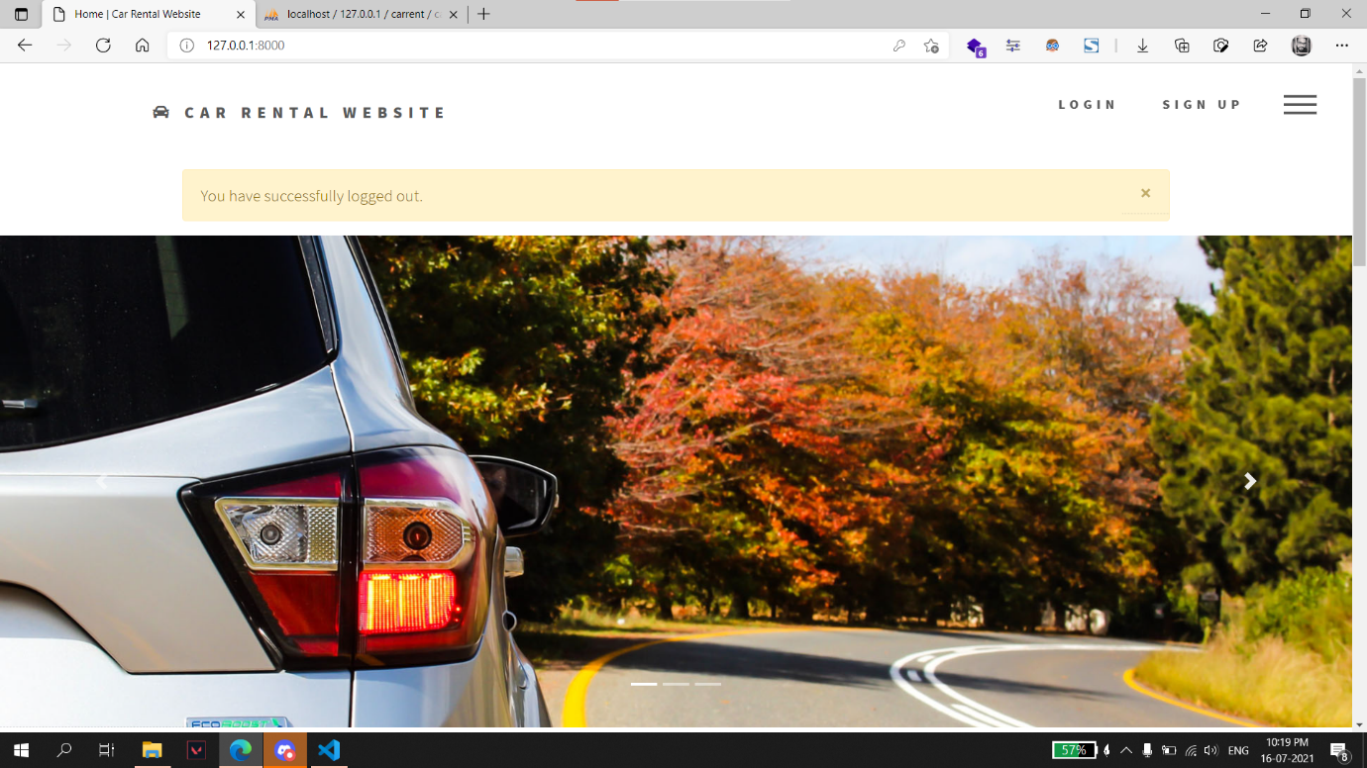

# Admin Side

**Car Model:**

**Admin can add, edit or delete car models from this page.**

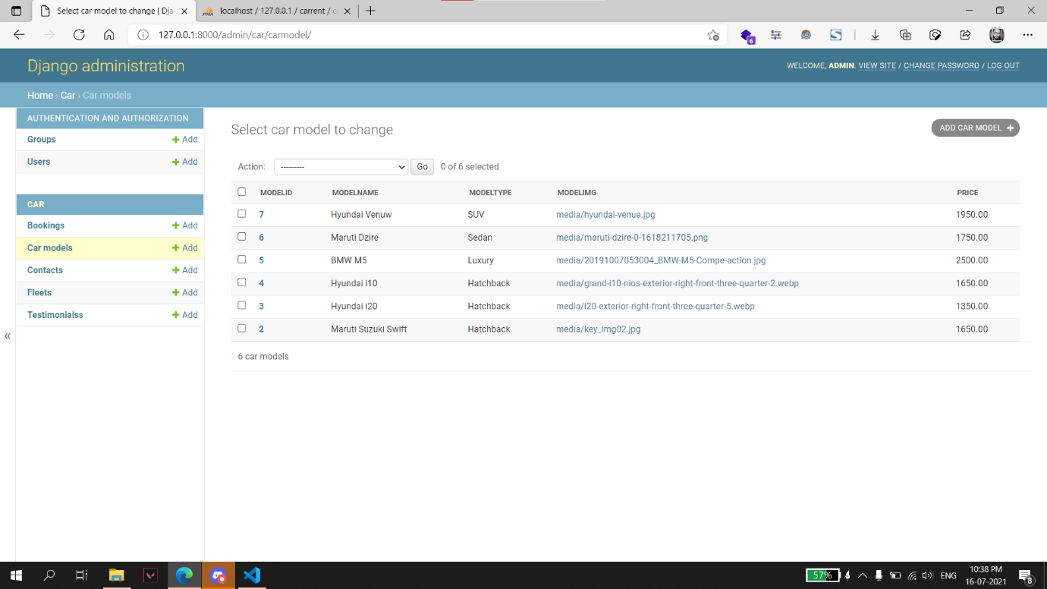

**Fleet:**

**Individual cars can be added, updated, or deleted from this page.**

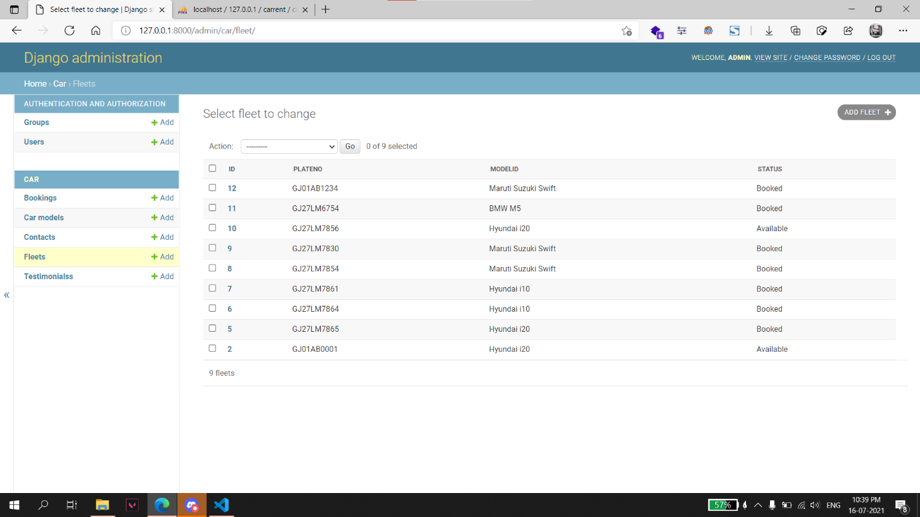

# 

**Queries from contact us page:**

**Admin can update status of queries from this page.**

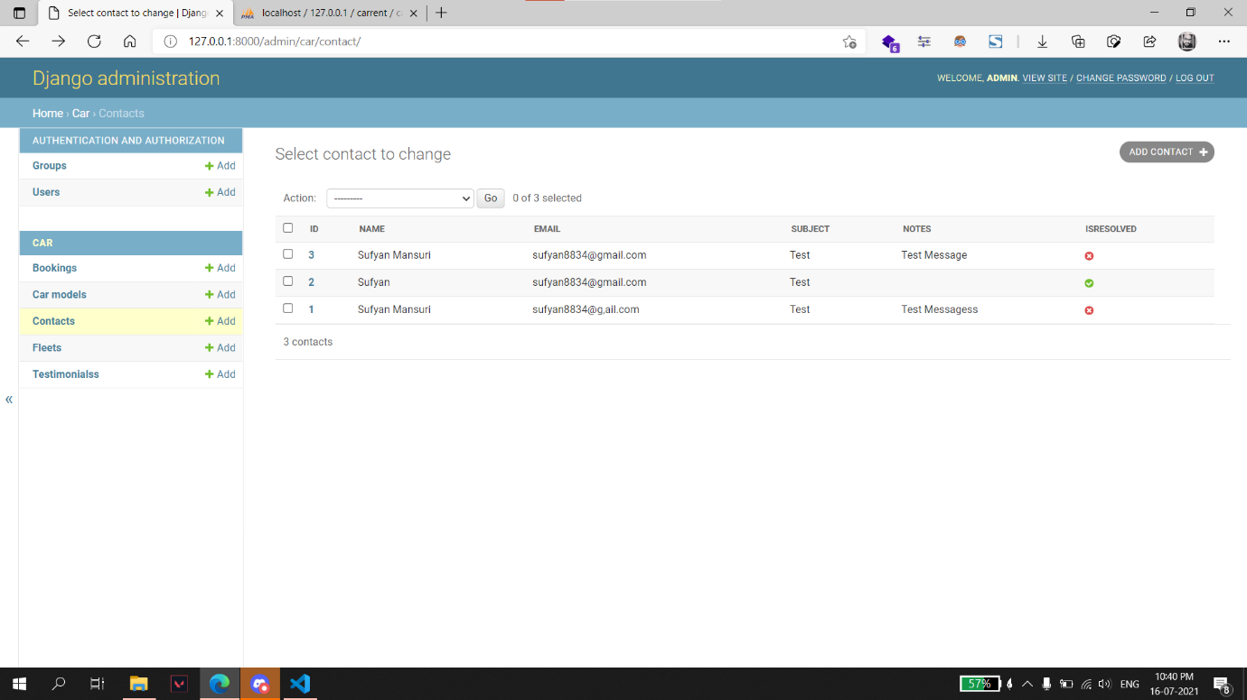

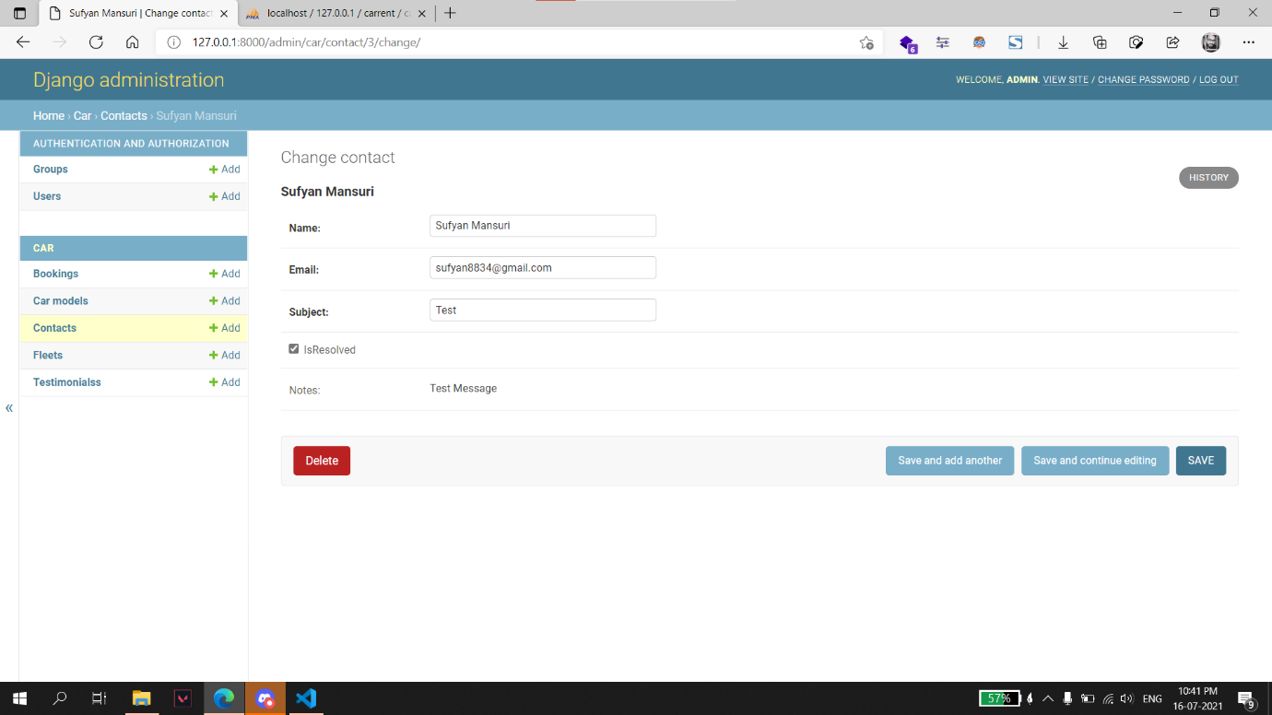

**Bookings:**

**Bookings can managed from this page.**

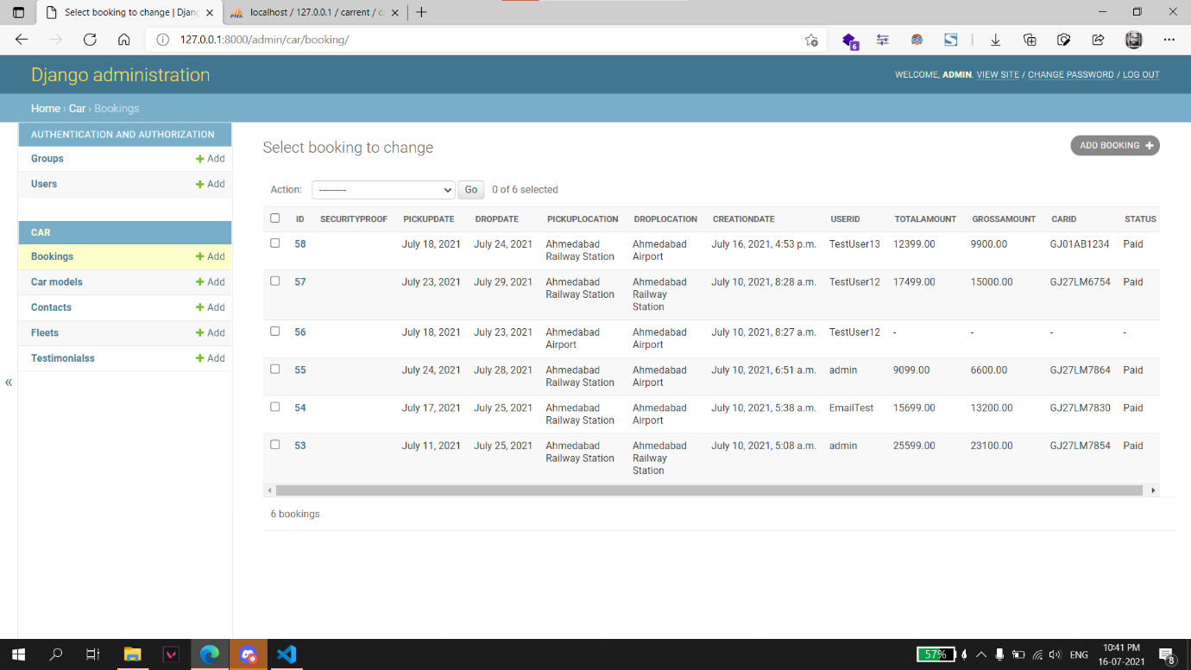

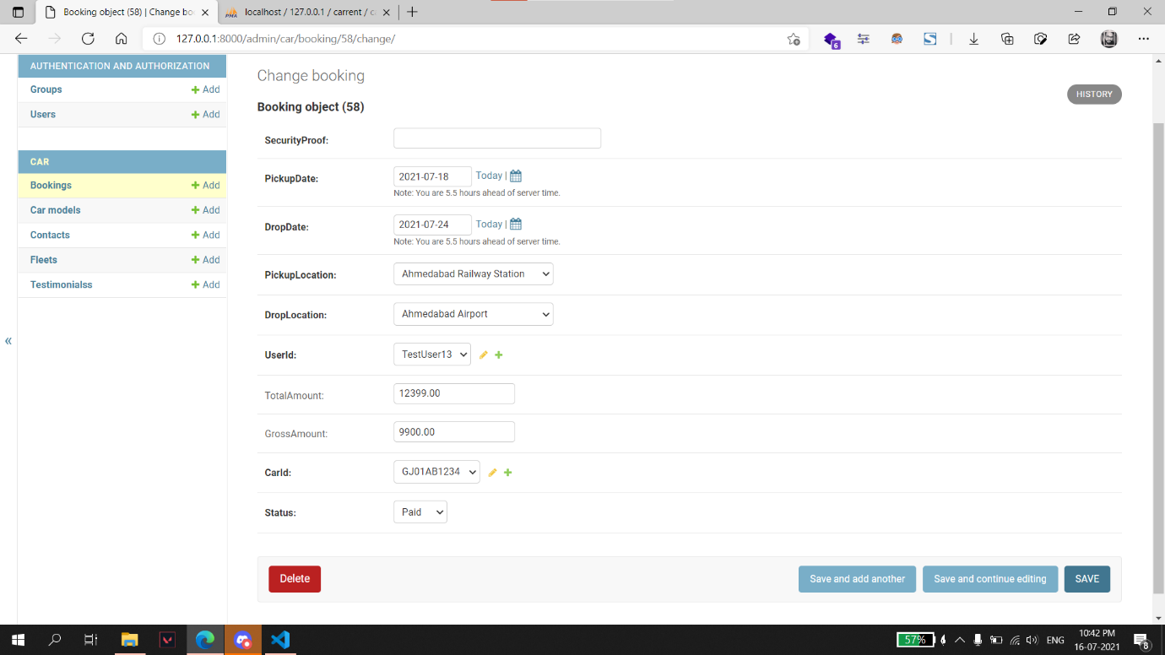

**Testimonials:**

**Admin can manage testimonials from this page.**

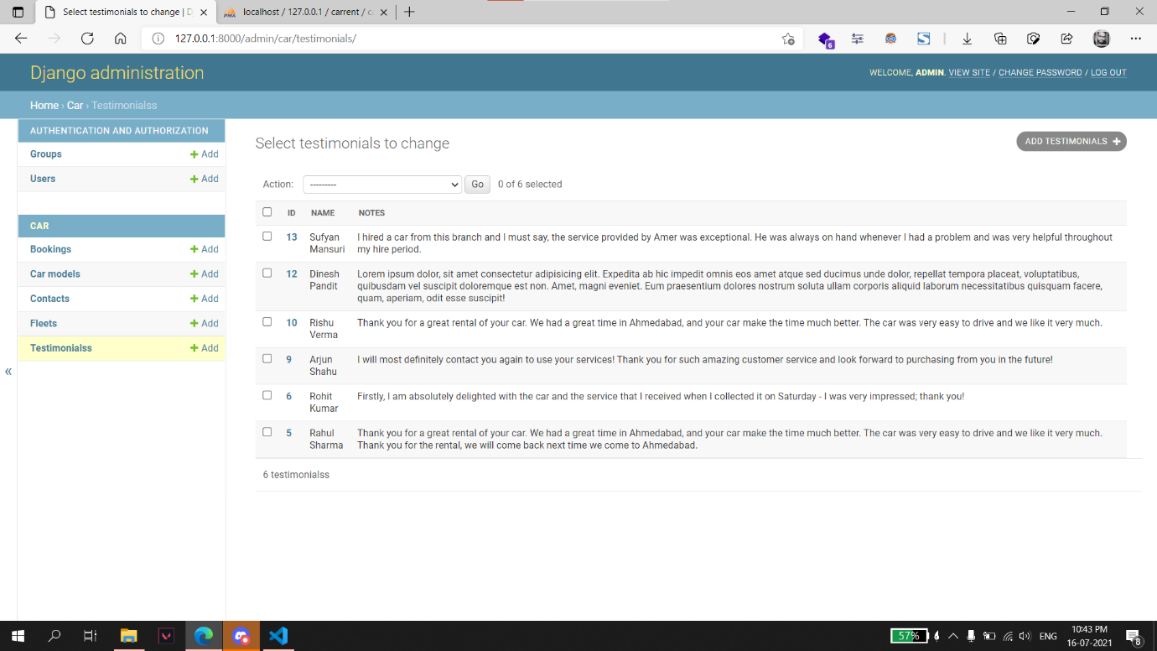

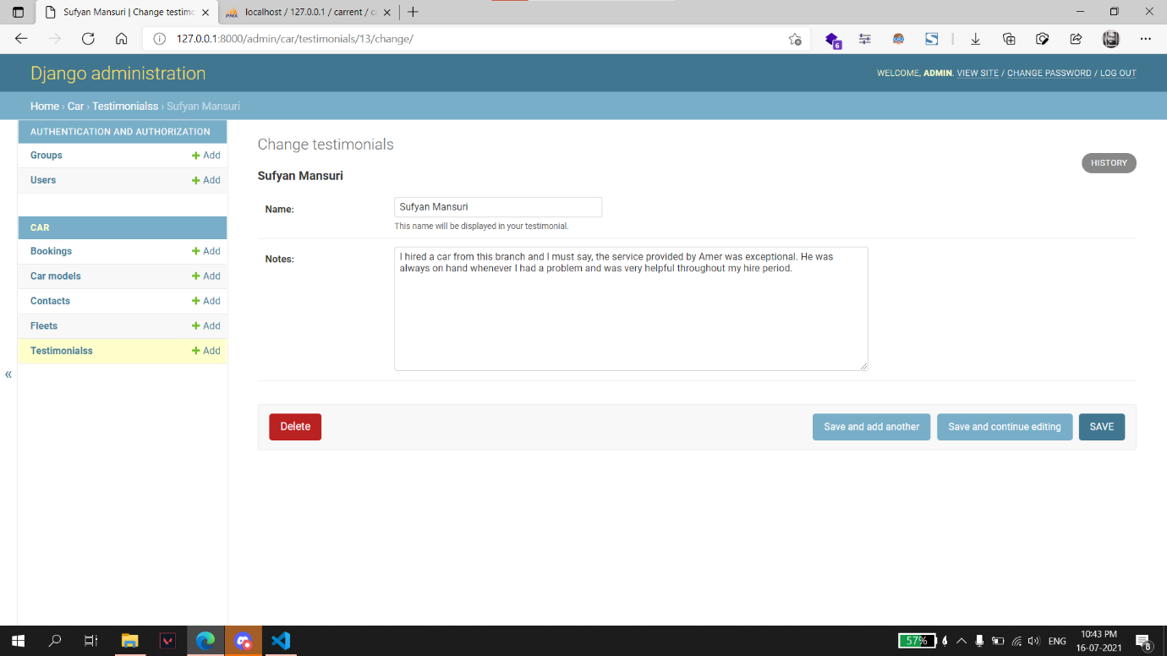

# **Proposed Enhancements:**

Enhancements in this project can be as follows

* Integrate payment gateway.
* Add functionality to manage bookings for customer.
* We are planning to add a new feature i.e., pay after the trip.
* We are working to increase automation in the system to increase user experience greatly.
* Add functionality to generate reports.

# **Conclusion:**

The web-based car rental system has offered an advantage to both customers as well as Car Rental Company to efficiently and effectively manage the business and satisfies customers’ need at the click of a button.

This project wanted to give customers and company an online platform, and it has given that platform using Django framework where customers can book car and company can approach the booking and respond accordingly.

**Bibliography:**

* Django Documentation
  + <https://docs.djangoproject.com/en/3.2/>
* YouTube
  + <https://www.youtube.com>
* Visual Studio Code
  + [https://code.visualstudio.com](https://code.visualstudio.com/)
* Visual Paradigm
  + <https://visual-paradigm.com>
* GitHub
  + <https://github.com>/harshil037/carrent.git
* Stack Overflow
  + <https://stackoverflow.com>
* XAMPP Server
  + <https://www.apachefriends.org/download.html>